Project Name
Date this version of the file is created

Table of Contents
How to build a TOC? It will auto-build for you if you use Styles. We will explain how to build a TOC later.

Learn to Make Your Software Work for You
Why this section?
Starting off with a document that has formatting, tables, figures, and its general look and feel will make your life easier as you work in multiple documents that you will create, and will lead to a consistent look and feel of your presented documentation.
This document is written in Word 2016 (on a Mac).
I state this, because in previous versions of Office on a Mac, there were some MAJOR differences that caused incompatibilities. I am not talking about a DOCX file not opening up on Macs or PCs, but I am specifically targeting extensive use of Styles, figures, and tables throughout a document.
In the past, even a minor pagination issues could change a PC version of a Word Doc from 114 pages, when opened on a Mac, to a 120 page version of the same file.
These issues no longer appear to be a concern, and Office 2016 seems to be identical on both PCs and Macs.
Styles
Let’s just start with styles. Styles are predefined font, size, paragraph, tab, and other formatting options defined. Once you have styles, you can apply styles to your documents. This makes continuity of formatting your document much easier.
Where can you find Styles? In the Ribbon, you will find Styles (you may need to change what you can see in YOUR view, but the feature is there).
Figure 1 - Finding Styles
See the multiple styles listed out? Once they are available (which means they have been created and defined), you can just select a paragraph of text, and apply a Style to it. MUCH easier than making sure the document is formatted correctly.
Included here is an example of the different Header styles that are included. Start with the gray bar identifying this as a new Section (the Styles Section top of this page). This is the style, “ITAR – H1”. It gets formatted as such when applied, and will always have a page break right before it, meaning that you get a new page to start a new section.
Look at the other headers here, which are ITAR – H2 through ITAR – H5.
ITAR – H2
Each of the header styles
ITAR – H3
ITAR – H4
ITAR – H5
ITAR – Body Test
ITAR – Callouts (callouts is not paragraph formatting, but rather ‘word’ formatting. Note that the rest of this text is just ITAR – Body Text).
ITAR – Commands (commands is not paragraph formatting, but rather ‘word’ formatting. Note that the rest of this text is just ITAR – Body Text).
ITAR – Title Large
ITAR – Title Small

How do you make and manage Styles? Simple.
Look at the following figure.
On macOS, you will see the Styles Pane.
On a Windows PC, you will see a little arrow in the bottom right corner of the Styles (window, in the ribbon).
Figure 2 – Managing Styles
You will now see a Window similar to the following, where you a list of styles. Note that ¾ of the way down, you see the List pull-down menu… This controls what styles you see in the list. Very useful when you have a lot of styles to work with.
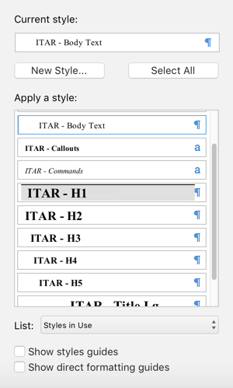
Figure 3 - Show & Manage Styles
Again, Windows and macOS present things differently.
On macOS, you move your cursor over the ¶ symbol, and you see a new pull down become available…
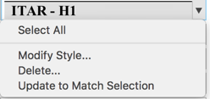
Figure 4 - Modifying a Style
Select Modify Style… to,…..well….modify the defined style….
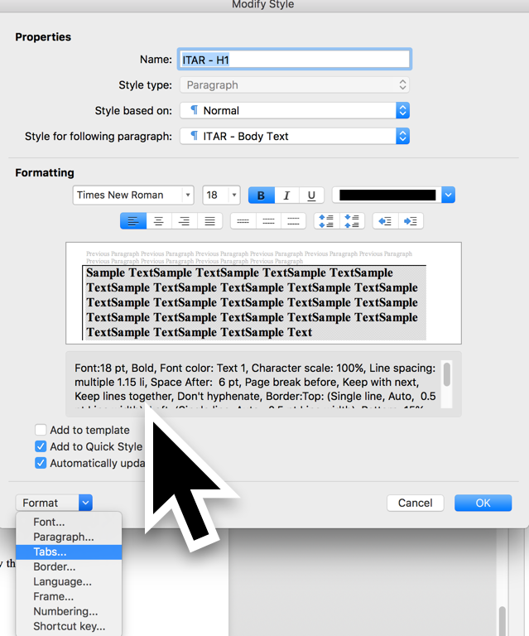
Figure 5 - The Details of a Style
You have a lot of control over all features of a Style. There is no way to configure it that works for everyone, as there are so many potential options to configure.
You can spend a lot of time creating your own styles paying attention to things like spacing between lines, spacing after a carriage return, spacing before and after a style…many, many different things.
Look at this style (which is ITAR – Body Test) by modifying the style, and format the paragraph. Look how you can easily control how much indentation is present in these paragraph types.
Should you make your own? You can, but please…use the ITAR styles if you would like. That is why we made this document available to you.

Using Tables

ID | Constraint | Source | Date Approved
C01 | Design will take into account server hardware in use by ITAR, the HP c7000 Class chassis and c-class blades | Infrastructure Manager
C02 | FlexFabric Virtual Connect interconnects are the preferred manner to connect the c7000 | Infrastructure Manager

